YEAR ? 90S?

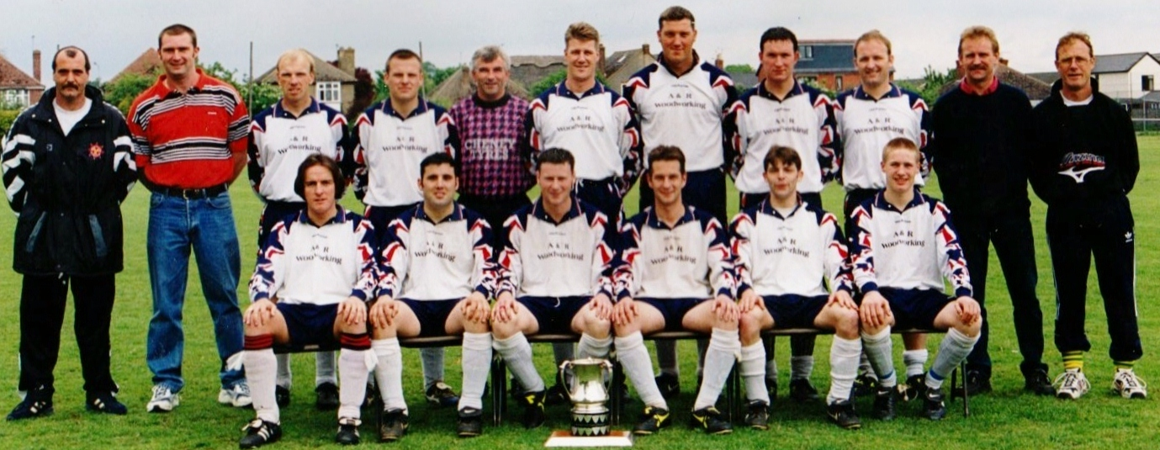

BACK ROW L/R FRONT ROW L/R

NEIL HODSON - MANAGER STEVE THOMPSON

SEAN LAPPER - TRESURER LEE BALL

IAN WALTERS CRAIG MERRY

SIMON REAM ADAM WITHERALL

MICK POND ROBERT CANAWAY

ANDY SWANN BEN HOWES

ROSS BUTLER

STEVE ROUND

STEVE HARRIS

MART IN HOWES - SECRETARY

MARK BIDWELL - CHAIRMAN